Student ID: 001158836
Programme of Study: MSc Electrical and Electronic Engineering

  POWER ELECTRONICS LOGBOOK  Dr. Yehdego Habtay | DISHA HARWALKAR  ELEE-1165- Power Electronic Converters

Table of Contents
1 BUCK CONVERTER LABORATORY 3
1.1 INTRODUCTION 3
1.2 ANALYTICAL COMPUTATION 3
a. Calculating the Values of the Inductor and Capacitor 3
b. Determining the Rated Values For the MOSFET, Diode and Capacitor 4
c. Analytically Determining the Effects of the Non-Ideal Characteristics on Voltage Conversion Ratio and Efficiency of Buck Converter 4
d. Calculating the Values of the Voltage Conversion Ratio and Efficiency 5
e. Sketch of Waveforms for Each Component 6
f. Critical Value of Load Resistance at Boundary of CCM and DCM 6
g. Critical Value of Frequency at Boundary of CCM and DCM 7
1.3 HARDWARE AND SOFTWARE REQUIREMENTS 7
1.4 PROCEDURE 7
1.5 DISCUSSION 14
1.6 CONCLUSION 15
2 FLYBACK CONVERTER LABORATORY 16
2.1 INTRODUCTION 16
2.2 ANALYTICAL COMPUTATIONS 16
2.3 PROCEDURE 17
2.4 DISCUSSION 20
2.5 CONCLUSION 20
3 CLOSED LOOP PWM CONTROLLER LABORATORY 22
3.1 INTRODUCTION 22
3.2 PROCEDURE 22
3.3 DISCUSSION 26
3.4 CONCLUSION 26

TABLE OF FIGURES
Figure 1 A buck converter with measuring devices 3
Figure 2 Sketch of expected waveforms 6
Figure 3 Inductor Current Waveform 7
Figure 4 Inductor Voltage Waveform 8
Figure 5 Capacitor Current Waveform 8
Figure 6 Capacitor Voltage Waveform 8
Figure 7 Load current waveform 9
Figure 8 Switch current waveform. 9
Figure 9 Switch voltage waveform 9
Figure 10 Diode current waveform 10
Figure 11 Diode voltage waveform 10
Figure 12 Input power waveform 10
Figure 13 Output power waveform 11
Figure 14 CCM and DCM boundary by load variation 12
Figure 15 CCM and DCM boundary by frequency variation 12
Figure 16 Buck Converter Designed in Proteus 13
Figure 17 Diode current and voltage waveforms 13
Figure 18 MOSFET Current and Voltage waveforms 13
Figure 19 Inductor current and Voltage waveforms 14
Figure 20 Load current and voltage waveforms 14
Figure 21 A flyback converter with measuring devices 16
Figure 22 Load current 17
Figure 23 Switch current 17
Figure 24 Switch voltage 17
Figure 25 Diode current 18
Figure 26 Diode voltage 18
Figure 27 Capacitor current 18
Figure 28 Capacitor voltage 19
Figure 29 Transformer primary voltage 19
Figure 30 Transformer secondary voltage 19
Figure 31 Buck Boost converter with closed loop control 21
Figure 32 PWM Signal 21
Figure 33 Output current 21
Figure 34 Output Voltage 22
Figure 35 Inductor Current 22
Figure 36 Output voltage 25

LIST OF TABLES
Table 1 Calculated and Measured Conversion Ratio and Efficiency 11
Table 2 Duty cycle comparison 11
Table 3 Frequency effects comparison 12
Table 4 Inductor comparison 12
Table 5 Calculated vs simulated values. 19
Table 6 Effects of Varying the Duty Cycle 20
Table 7 Effects of Varying the Frequency 20
Table 8 Measured vs Calculated Values. 23

BUCK CONVERTER LABORATORY

INTRODUCTION
A buck converter is a non-isolated dc to dc converter widely used in industry to convert a higher input voltage to a lower output voltage efficiently. The converter consists of an active switch - usually a MOSFET- controlled by a pulse generator, a rectifier, and filter elements as shown in Figure 1. The buck converter operates in two modes which are the Continuous Conduction Mode (CCM) and Discontinuous Conduction Mode (DCM). This experiment will study the components, control mechanism and filtering in a typical buck converter.
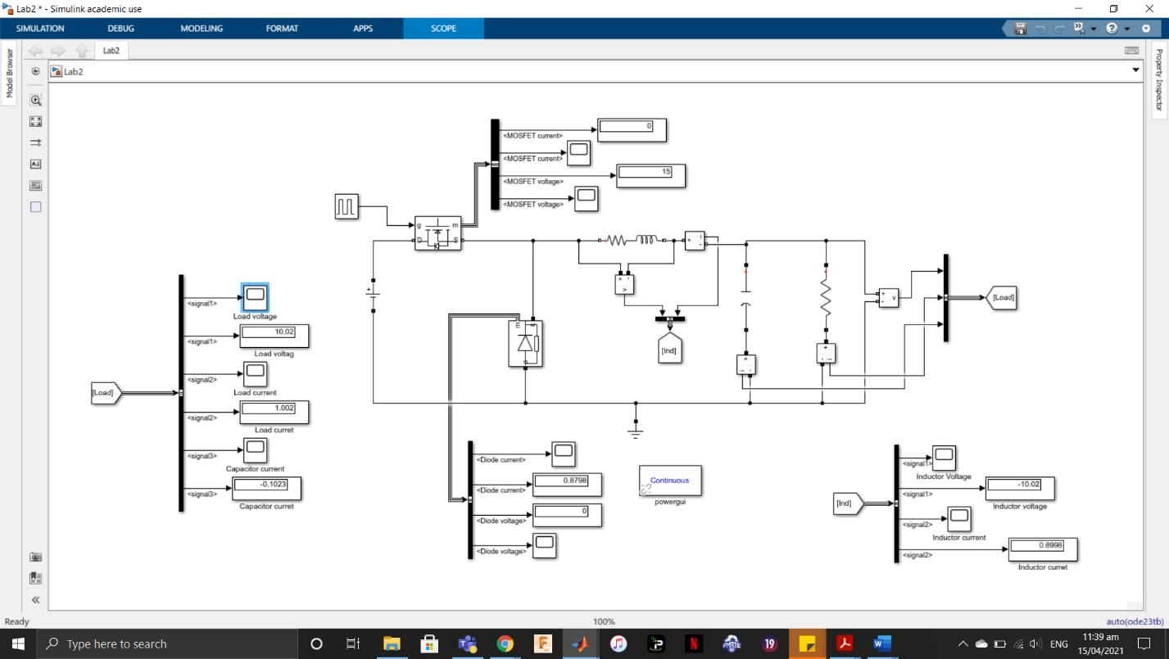
Figure 1 A buck converter with measuring devices
Figure 1 shows the circuit that was constructed in MATLAB Simulink. The next subtopic will contain the parameters and manual computation used to aid understanding of the operation of a buck converter without simulation.

ANALYTICAL COMPUTATION
In this subtopic, the values of certain parameters were evaluated using manual computations. The typical buck converter which had the following parameters was studied. The buck converter had an input voltage of 15V and was required to supply a 10 Ohms load with 10V and 1A. The pulse generator had a switching frequency of 125KHz. The inductor current ripple and output voltage peak to peak ripples were expected not to exceed 20% and 1 % respectively.

Calculating the Values of the Inductor and Capacitor
To determine the value of the inductor and capacitor to be used, the value of the duty cycle D was calculated,
$$D=\frac{v_{g}}{v}=\frac{10}{15}=0.667$$
The values of the permitted inductor current ripple and output voltage peak to peak ripples were also calculated,
$$∆I_{L}=\frac{20}{100}×1=0.2A$$
$$∆V_{C}=\frac{1}{100}×10=0.1V$$
The value of the inductor and capacitor were then determined as follows,
$$L=\frac{\left(V_{g}-V\right)DT_{s}}{∆i_{L}}$$
$$L=\frac{(15-10)×0.667}{125×{10}^{3}×0.2}$$
$$L=133.4μH$$
and
$$C=\frac{∆i_{L}}{F_{SW}×8×∆V}$$
$$C=\frac{0.2}{125×{10}^{3}×8×0.1}$$
$$C=2μF$$

Determining the Rated Values For the MOSFET, Diode and Capacitor
Determining the rated values for the components requires deducing a component that can be used for the application while justifying the selection. The components determined were the MOSFET, Diode and Capacitor.

MOSFET
The minimum voltage that the MOSFET will be required to block during OFF state is 15V. Therefore, the MOSFET should be rated above 15V. The minimum current the MOSFET will be subjected to is 1A. Therefore, a 20V and 2A rated MOSFET would be optimal.

Diode
The minimum voltage that the Diode will be required to block during the ON state is 15V. A diode capable of blocking voltage above 15V should be selected. It would be subjected to a current of about 1A. Therefore, a 20V and 2A rated diode should be selected for this operation.

Capacitor
The minimum voltage that the Capacitor will be required to withstand will be an output voltage of 10V. The selected capacitor should be rated above 10V. The current the capacitor would be subjected to will range from 0 to about 1A. Therefore, selecting a 15V and 2A rated capacitor would be optimal.

Analytically Determining the Effects of the Non-Ideal Characteristics on Voltage Conversion Ratio and Efficiency of Buck Converter
There are factors that affect the voltage conversion ratio and efficiency of a buck converter. These factors are the ON resistance of the MOSFET R_{DSON}, the diode voltage drop V_{DON}, the inductor winding resistance R_{L}, and the Equivalent Series Resistance (ESR) of Capacitor.
To derive the equation of the voltage conversion ratio and the efficiency which are affected by non-ideal characteristics, the capacitor ESR was not considered because it does not significantly affect the voltage drop in the buck converter. The equations are derived below,
During ON time
$V_{LON}=V_{g}-I_{O}R_{DSON}-I_{O}R_{L}-V_{O}$ … (1)
During OFF time
$V_{LOFF}=-V_{O}-V_{DON}-I_{O}R_{L}$ … (2)
Equation (1) and (2) were substituted into the Volt Second Balance equation
$$V_{LON}DT+V_{LOFF}\left(1-D\right)T=0$$
$$V_{g}D-I_{O}R_{DSON}+V_{DON}D-V_{O}-V_{DSON}-V_{DON}D-I_{O}R_{L}=0$$
$$D=\frac{V_{O}+I_{O}R_{L}+V_{DON}}{V_{g}-I_{O}R_{DSON}+V_{DON}}$$
To find the Efficiency of the buck converter,
$$η=\frac{P_{O}}{P_{IN}+P_{losses}}×100\%$$
The formula for the power loss is given below.
$$P_{losses}=P_{cond}+P_{swloss}$$
The formulas for the switching and conduction losses are given below,
$$P_{switch}=\frac{1}{2}V_{g}I_{O}(t_{sw_{off}}+t_{swon})f_{sw}$$
$$P_{conduction}=\left({I^{2}}_{O}R_{DSON}×D\right)+0.7I_{O}\left(1-D\right)+{I^{2}}_{O}R_{L}$$

Calculating the Values of the Voltage Conversion Ratio and Efficiency
The values of the voltage conversion ratio and the efficiency were calculated as shown below,
$$D=\frac{10+0.064+0.68}{15-0.016+0.68}$$
D= 0.686
$$P_{swloss}=\frac{1}{2}×15×1×2\left(78+48\right)×{10}^{-9}×125×{10}^{3}$$
(the rise time and fall time were gotten from the MOSFET datasheet and is multiplied by 2 to get the on time and off time)
$$P_{swloss}=0.236W$$
The value of inductor resistance = 0.064 ohms used is gotten from the ATCA-05-141M datasheet which is a 140uH inductor. The site used was mouser.co.uk
The diode forward voltage V_{DON} = 0.68 V and MOSFET R_{DSON} = 0.016 Ohms were gotten from the datasheets of MUR405G and IRFIZ48NPBF, respectively.
The conduction loss is given below,
$$P_{conduction}=\left({I^{2}}_{O}R_{DSON}×D\right)+0.7I_{O}\left(1-D\right)+{I^{2}}_{O}R_{L}$$
$$P_{cond}=\left(1^{2}×0.016×0.68\right)+0.71\left(1-0.68\right)+1^{2}×0.064$$
$$P_{cond}=0.302W$$
Summing up the conduction and switching losses,
$$P_{losses}=0.236+0.302$$
$$P_{losses}=0.538W$$
The efficiency is thus calculated,
$$η=\frac{I_{O}V_{O}}{I_{O}V_{O}+P_{losses}}×100$$
$$η=\frac{10}{10+0.538}×100$$
$$η=94.9\%$$

Sketch of Waveforms for Each Component
The expected waveforms for the components were sketched in Figure 2.
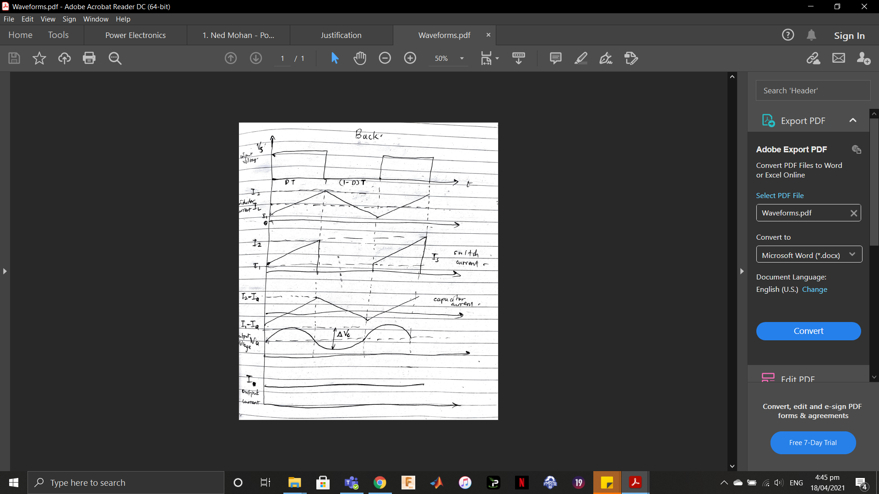
Figure 2 Sketch of expected waveforms

Critical Value of Load Resistance at Boundary of CCM and DCM
The critical value for the load resistance at the boundary of the Continuous Conduction Mode and Discontinuous Conduction Mode was calculated as follows,
$$I_{L}=\frac{V_{O}}{R}=\frac{DV_{g}}{R}$$
Find I_{L} minimum
$$I_{L}-\frac{∆I_{L}}{2}=\frac{DV_{g}}{R}-\frac{\left(V_{g}-V_{O}\right)DT}{2L}$$
Equate the above equation to zero.
$$\frac{DV_{g}}{R}-\frac{\left(V_{g}-V_{O}\right)DT}{2L}=0$$
$$R=\frac{2Lf_{sw}}{\left(1-D\right)}$$
$$R=\frac{2×133.4µ×125×{10}^{3}}{\left(1-0.667\right)}$$
$$R=100.15Ω$$

Critical Value of Frequency at Boundary of CCM and DCM
The critical value for the frequency at the boundary of the Continuous Conduction Mode and Discontinuous Conduction Mode was calculated as follows,
$$f_{sw}=\frac{R(1-D)}{2L}$$
$$f_{sw}=\frac{10(1-0.667)}{2×133.4µ}$$
$$f_{sw}=12.48KHz$$

HARDWARE AND SOFTWARE REQUIREMENTS
The hardware used for this experiment was a University of Greenwich desktop computer at the Nelson building on Medway campus which has a core i5 8th generation processor. The software used for this lab were MATLAB Simulink© and Proteus.

PROCEDURE
The non-ideal characteristics for the MOSFET and diode were included in the designed circuit as shown in Figure 1. The inductor resistance R_{L} was added to the inductor as a resistor in series with it. The waveforms of each components over 3 switching intervals are shown below.
- Inductor
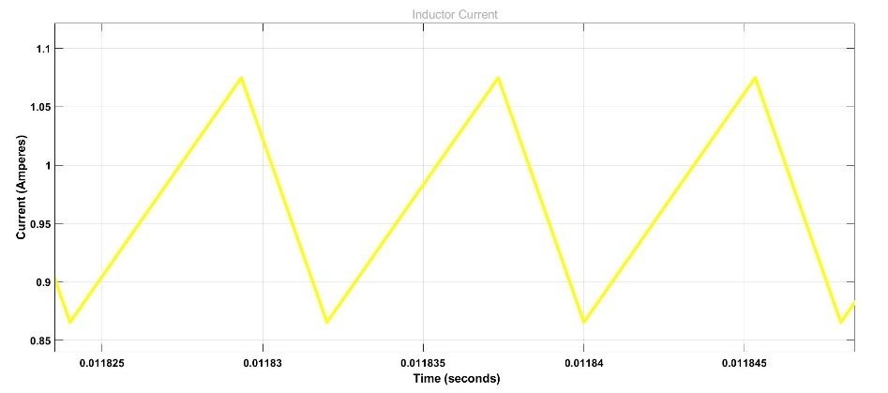
Figure 3 Inductor Current Waveform
The inductor ripple measured here is 0.2091A
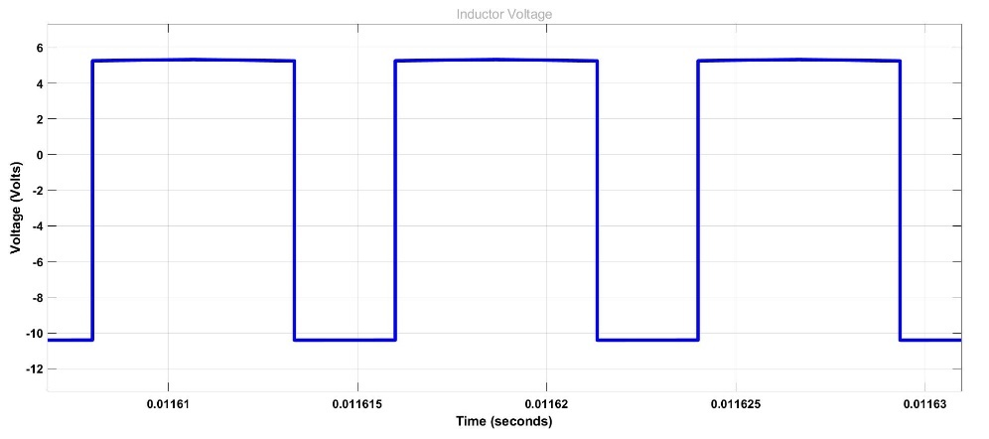
Figure 4 Inductor Voltage Waveform
- Capacitor
The waveform for the capacitor current and voltages over three switching cycles are given below.
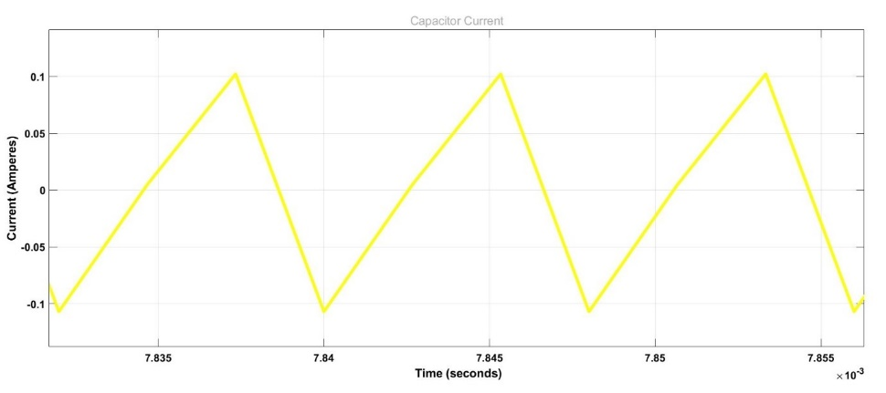
Figure 5 Capacitor Current Waveform
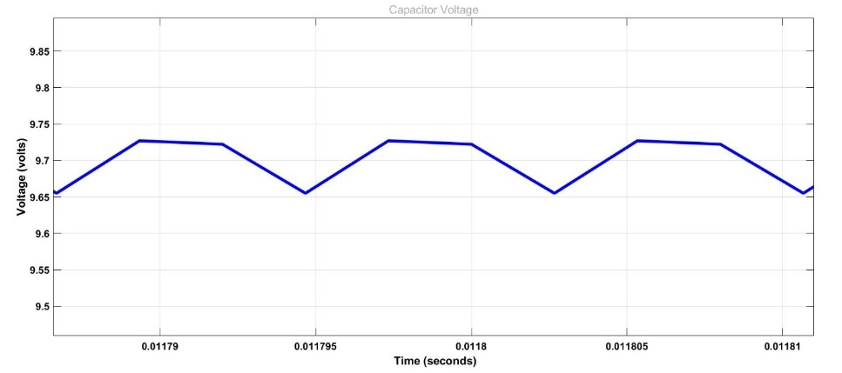
Figure 6 Capacitor Voltage Waveform
The measured capacitor voltage ripple is 0.07187V
- Load
The waveform for the load voltage is a duplicate of the capacitor. The waveform for the load current is shown below.
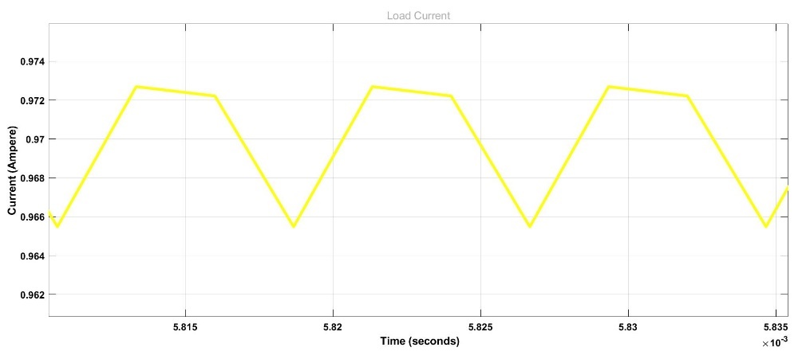
Figure 7 Load current waveform
- Switch (MOSFET)
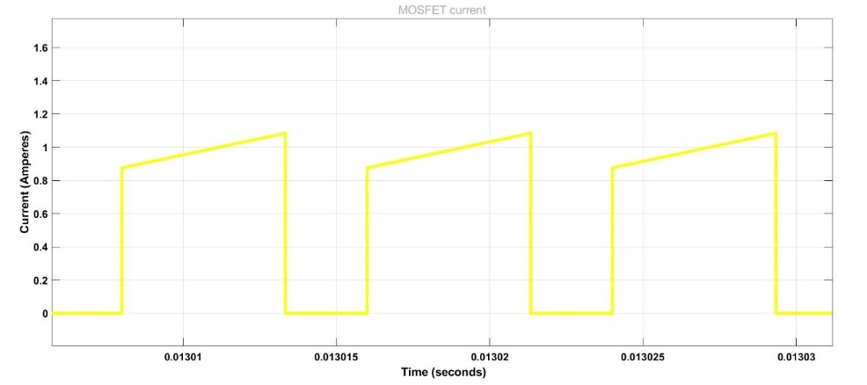
Figure 8 Switch current waveform.
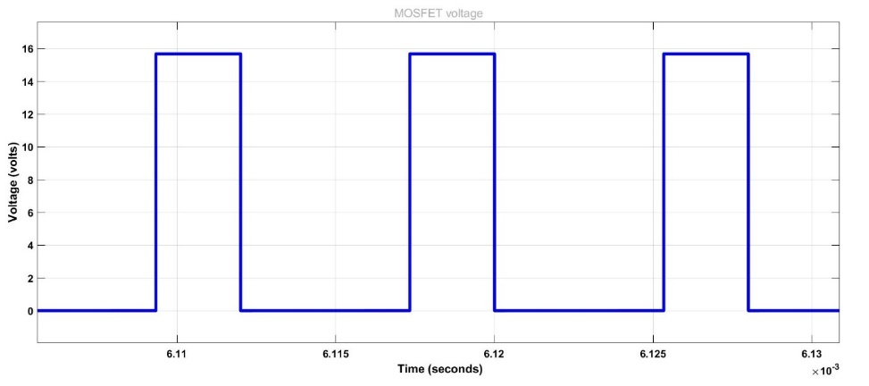
Figure 9 Switch voltage waveform
- Diode
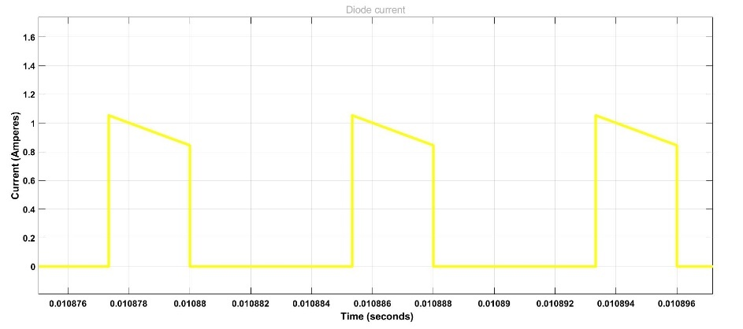
Figure 10 Diode current waveform
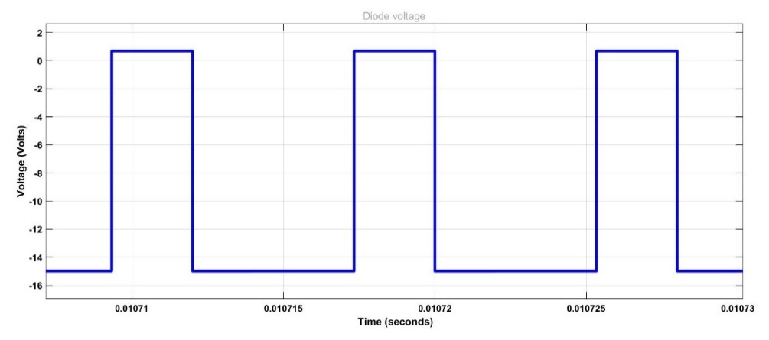
Figure 11 Diode voltage waveform
- Power
A power measurement block was used to measure the input and output power. Their waveforms are shown.
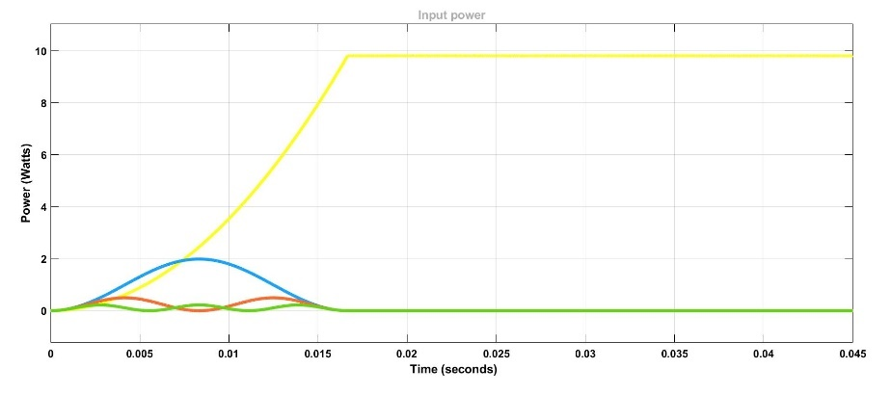
Figure 12 Input power waveform
The value for the input power was measured as 9.806W.
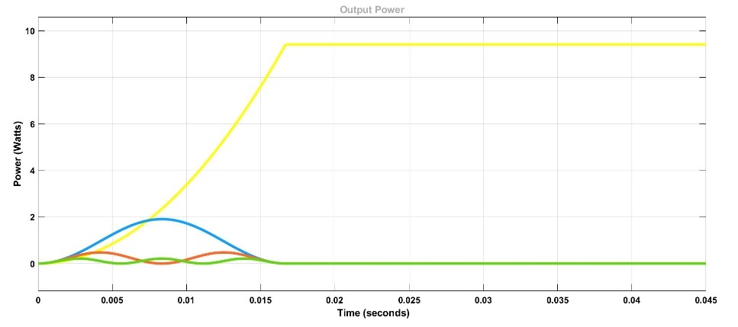
Figure 13 Output power waveform
The value for the output power is measured as 9.412W
- Voltage Conversion Ratio and Efficiency
The calculated and measured conversion ratios and efficiencies are shown below.
Table 1 Calculated and Measured Conversion Ratio and Efficiency
 | Calculated | Measured | Error (%)
Conversion Ratio | 0.686 | 0.648 | 5.5
Efficiency | 94.9 % | 95.9 % | 1

Investigating Impacts of Changing the Duty Cycle, Load, Switching Frequency, and Inductance.
- Duty Cycle
The duty cycles were adjusted between these values 33.33%, 66.67% and 83.34% and their effects were compared in the table below.
Table 2 Duty cycle comparison
 | 33.33% Duty Cycle | 66.67% Duty Cycle [Normal] | 83.34% Duty Cycle
Output voltage, V_{O} | 4.489 V | 9.722 V | 12.31 V
Peak-to-peak Inductor Current Ripple, $∆I_{L}$ | 0.2095 A | 0.2091 A | 0.1304 A
Peak-to-peak Capacitor Voltage Ripple, $∆v$ | 0.072 V | 0.07187 V | 0.03668 V
Output Power | 2.038 W | 9.412 W | 15.11 W

- Load
The instructions were to reduce the load but reducing the load increased the current rather than bringing it closer to the boundary of the Continuous Conduction Mode (CCM) and Discontinuous Conduction Mode (DCM). Therefore, the load was increased.
The CCM and DCM boundary was reached at 110 Ohms and the inductor current waveform is shown.
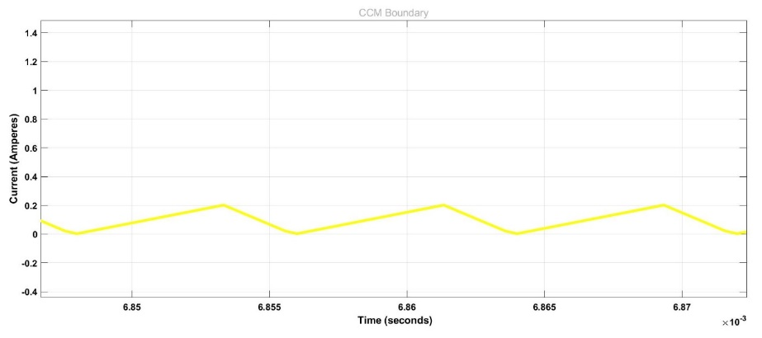
Figure 14 CCM and DCM boundary by load variation
- Frequency
The frequency was reduced until the inductor current reached the boundary between CCM and DCM which was about 17.1KHz as shown below.
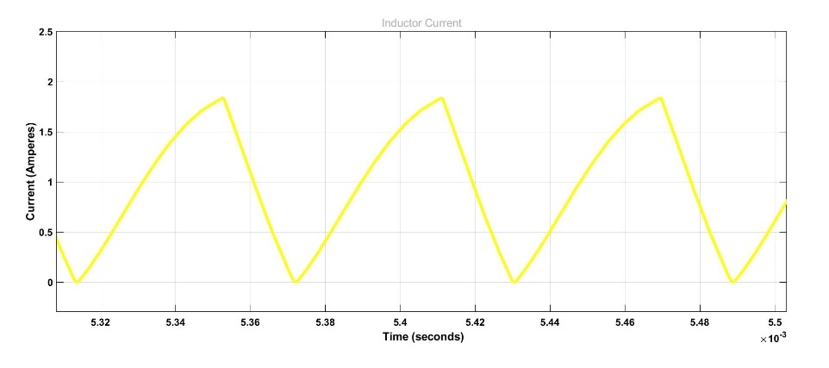
Figure 15 CCM and DCM boundary by frequency variation
The frequency of the pulse generator was changed to 250KHz. Some parameters were compared with the original as shown in the table below.
Table 3 Frequency effects comparison
 | 125 KHz | 250 KHz
Output voltage, V_{O} | 9.722 V | 9.707 V
Peak-to-peak Inductor Current Ripple, $∆I_{L}$ | 0.2091 A | 0.1039 A
Peak-to-peak Capacitor Voltage Ripple, $∆v$ | 0.07187 V | 0.01727
Output Power | 9.421 W | 9.412 W

- Inductor
The values of the inductor were modified and the effect on the inductor current, inductor current ripple and output voltage ripple are shown in the table below.
Table 4 Inductor comparison
 | 50 uH | 133.4 uH | 400 uH
Average Inductor Current, I_{L} | 0.6889 A | 0.8654 A | 0.9353 A
Peak-to-peak Inductor Current Ripple, $∆I_{L}$ | 0.5609 A | 0.2091 A | 0.0694 A
Peak-to-peak Capacitor Voltage Ripple, $∆v$ | 0.1934 V | 0.07187 V | 0.0238 V

- Proteus
The Proteus application was used to simulate the buck converter circuit as shown below.
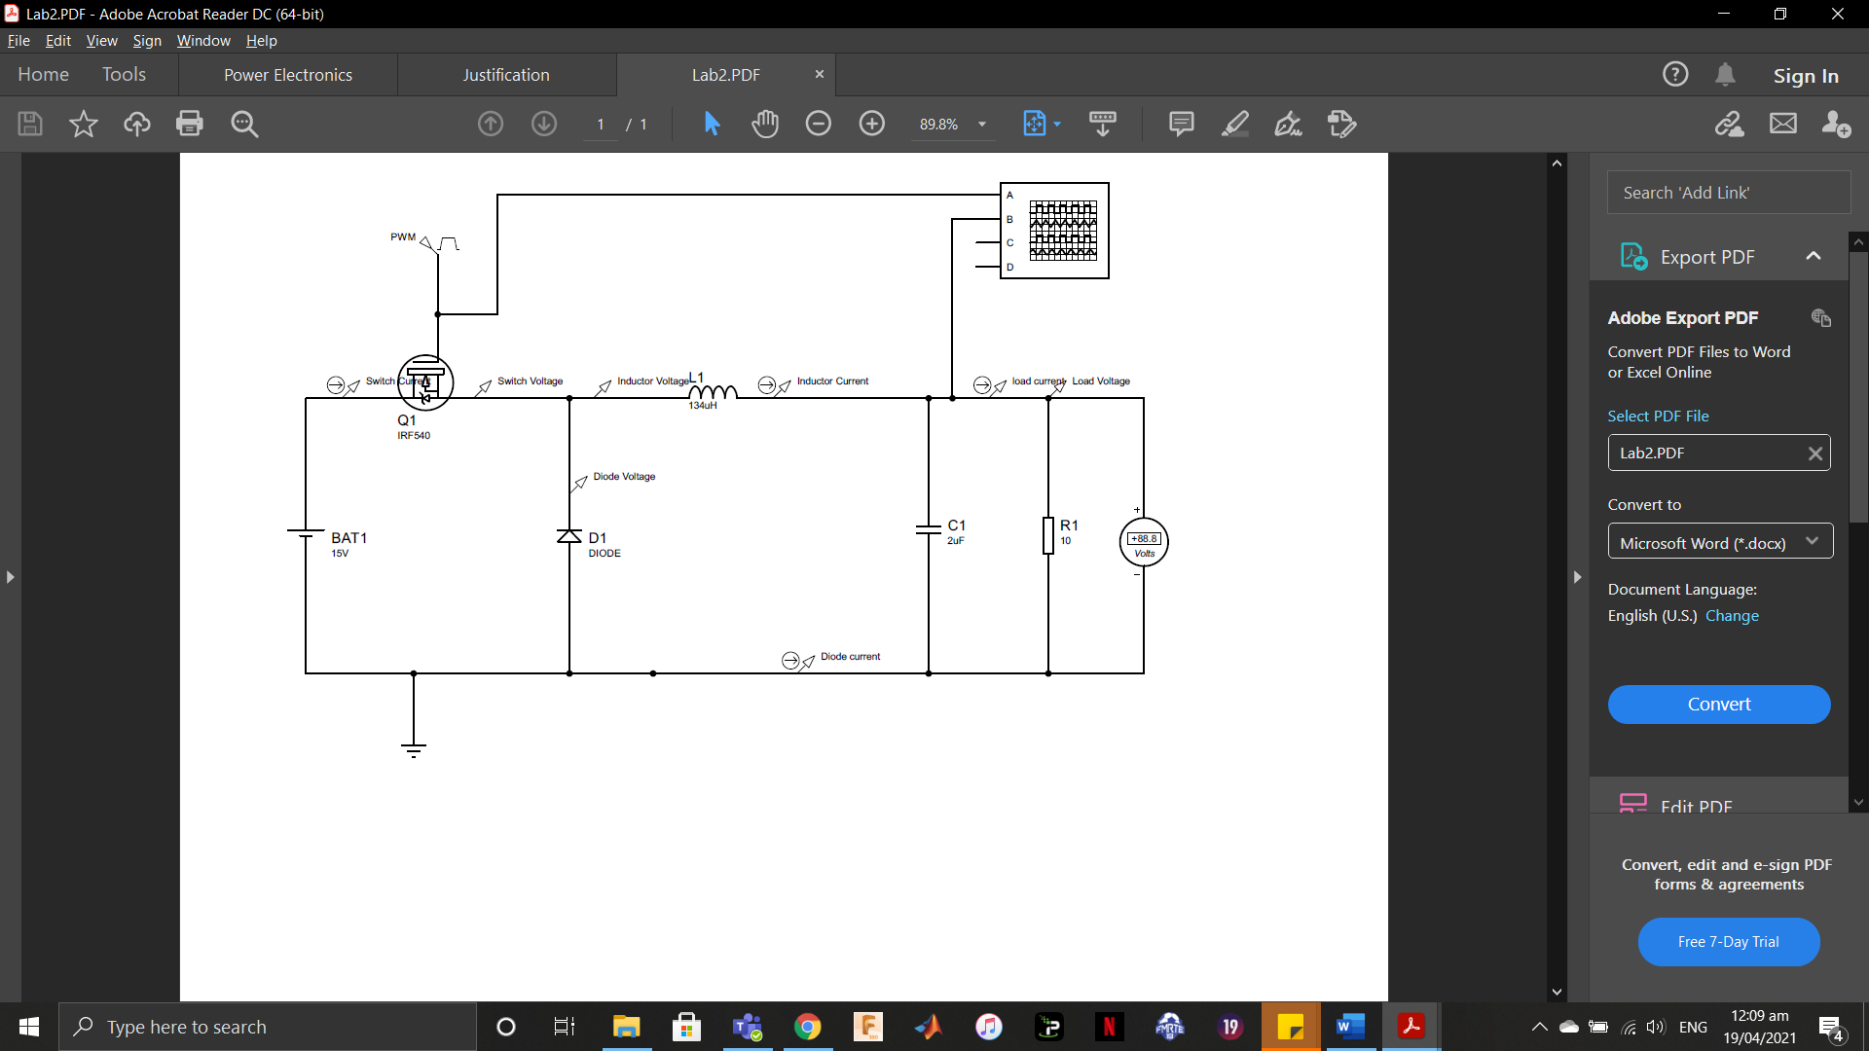
Figure 16 Buck Converter Designed in Proteus
The waveforms are given below.
Diode
Figure 17 Diode current and voltage waveforms

MOSFET
Figure 18 MOSFET Current and Voltage waveforms

Inductor
Figure 19 Inductor current and Voltage waveforms
Load
Figure 20 Load current and voltage waveforms

The input power was measured as 9.3W, output power was 5.46W. Voltage conversion ratio was measured as 0.492 while efficiency was 58.7%

DISCUSSION
The measured inductor current ripple in Figure 3 matches the analytical results calculated as the measured current ripple (0.2091 A) was similar to the calculated inductor current ripple which had a value of 0.2 A. The measured capacitor voltage ripple in Figure 6 had a value of 0.07187 V which was similar to the calculated value of 0.1 V. The inductor voltage waveform in Figure 4 was expected because during the ON time the inductor voltage rises to Vg-V = 15-10 = 5 V and during the OFF time the inductor voltage reduces to -V = -15 V as shown in Figure 4.
The duty cycle used with the switch (or MOSFET) is responsible for the switch and diode voltage waveforms blocking voltage for the OFF and ON times respectively in Figures 9 and 11. The inductor current in Figure 3 is the combination of the switch and diode currents in Figure 8 and 10 because the switch charges the inductor during ON time and the inductor discharges into the diode during OFF time. Meanwhile, the inductor and the capacitor supply the load during the OFF time as shown in the current waveforms of the inductor, capacitor, and load current in Figures 3, 5 and 7.
The input and output power in Figures 12 and 13 were slightly under 10 W due to non-ideal characteristics added and internal losses in the components. The calculated and measured values in Table 1 are very similar. The efficiency was not 100% due to the losses added.
The duty cycle was varied as shown in Table 2 and it shows that an increase in duty cycle of a buck converter would result in an increase in the output voltage. The voltage and current ripples increased during a decrease in the duty cycle but was not significant. The output power also increased with an increase in the duty cycle. This means the magnitude of the voltage output can be controlled by varying the duty cycle.
The inductor reached the boundary of CCM and DCM in Figure 14 when the load was increased to 110 Ohms. The calculated value was 100.15 Ohms. A nearly 10 Ohms difference was observed. The inductor reached the boundary of CCM and DCM in Figure 15 when the frequency was set to 17.1Khz. The calculated value was 12.48 KHz. Therefore, exceeding the limits should be avoided.
The frequency of 125KHz was increased to 250KHz in Table 3 and the output voltage reduced but not significantly, the ripples in the inductor current and capacitor current reduced and the output power reduced. This means the switching frequency can be increased to reduce the size of the filtering elements.
The inductor was varied as shown in Table 4. Increasing the inductor means increasing the average inductor current. Increasing the inductor value also decreased the amount of ripples in the inductor current and output voltage.
The buck converter designed on Proteus were not adjusted (given non ideal characteristics) because the components already had non idealities which dropped the output voltage heavily to about 7V. Therefore, the efficiency was very low at 58.7%

CONCLUSION
A buck converter is used to efficiently convert a higher input voltage to a lower output voltage. In this experiment, a buck converter was modelled and simulated on Simulink and Proteus application. The expected parameters were calculated before the experiment and the waveforms were extracted. The simulated and calculated models were similar in values. The effects of varying parameters such as the duty cycle, inductor values and switching frequency were studied. It was found that increasing the duty cycle increases the output voltage, increasing the switching frequency reduces ripples and increasing the inductor value reduces ripples. It can be concluded that in applications where space is important increasing the frequency might be more suitable than increasing the size of inductor while the opposite is applicable for applications where space is not important.

FLYBACK CONVERTER LABORATORY

INTRODUCTION
Flyback converters are isolated DC to DC buck-boost converters that use a coupled inductor as opposed to an isolation AC transformer as shown in figure 21. It can operate in two modes which are the Continuous Conduction Mode (CCM) and the Discontinuous Conduction Mode (DCM).
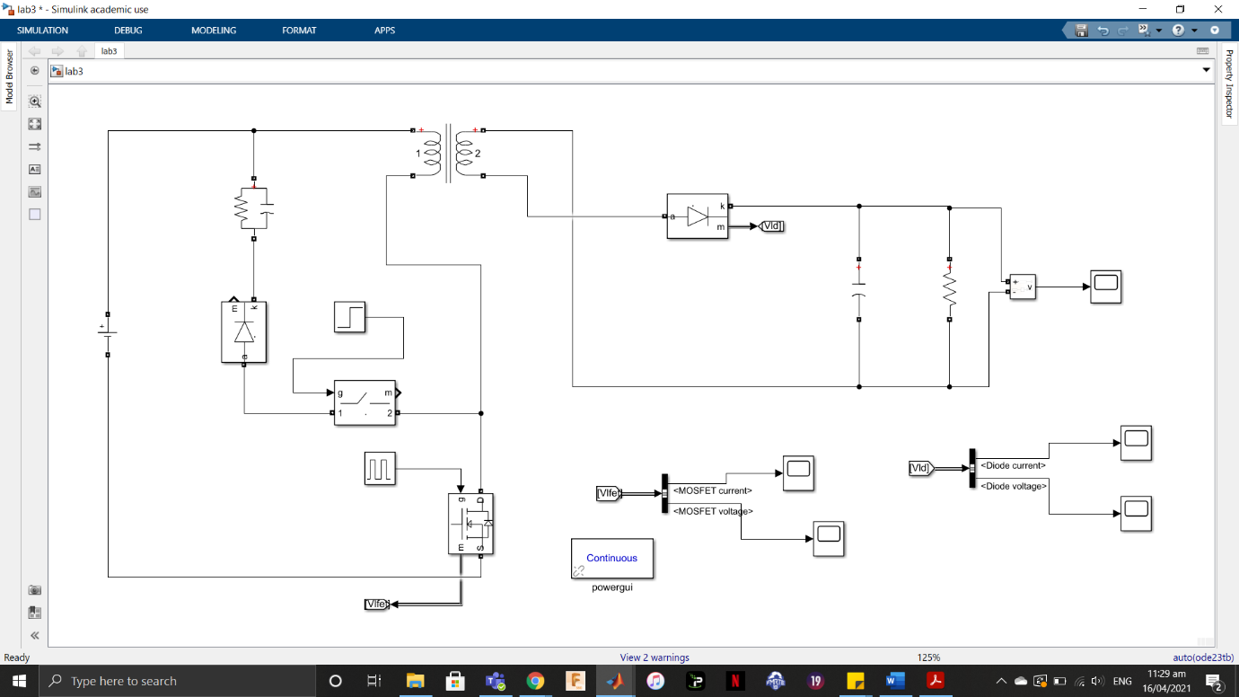
Figure 21 A flyback converter with measuring devices
The flyback converter stores energy during the ON state and transfers it to the load during the OFF state. In theory, the voltage gain of the flyback is infinite. Since it does not transfer energy directly, the flyback converter is mostly used in low power applications (typically below 100W). Figure 21 shows the design of a flyback converter using the MATLAB Simulink software by MathWorks®.

ANALYTICAL COMPUTATIONS
The magnetizing inductor current ripple $∆i_{LM}$, capacitor voltage ripple, switching voltage and diode voltage during ON time have been calculated below,
$$∆i_{LM}=\frac{V_{g}}{L_{M}}×DT$$
$$∆i_{LM}=\frac{150×0.343}{100}$$
$∆i_{LM}=0.5145 A$,
$$∆V_{C}=\frac{-V_{O}}{RC}DT$$
$$∆V_{C}=\frac{-15×0.343}{200}$$
$∆V_{C}=-0.02575 V$,
$$V_{SW}=V_{g}+V_{O}\frac{N1}{N2}$$
$V_{SW}=150+15\left(\frac{150}{30}\right)=225 V$,
$$V_{D}=-V_{O}-V_{g}\left(\frac{N2}{N1}\right)$$
$$V_{D}=-15-150\left(\frac{30}{150}\right)=-45 V$$

PROCEDURE
For this simulation, the values inputted into the linear transformer were converted to RMS values where necessary by dividing it by $√2$. The relevant waveforms for the inductor, switch (MOSFET), load, diode, capacitor, and transformer are shown below.
- Load
The current waveform for the load is coloured yellow while the voltage waveform is coloured blue, and they are shown below.
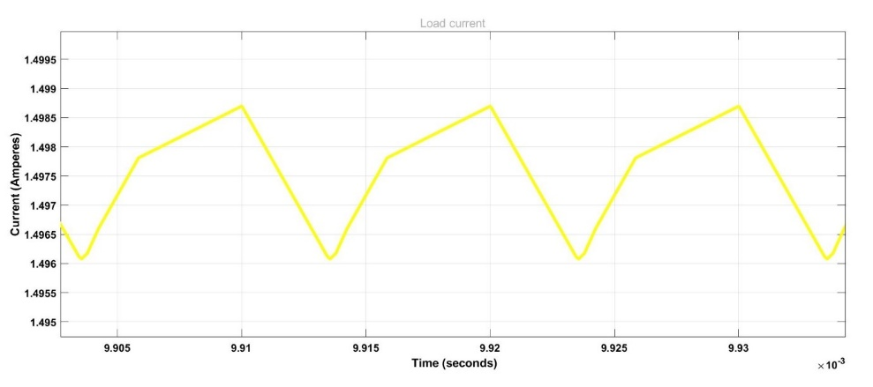
Figure 22 Load current
- Switch
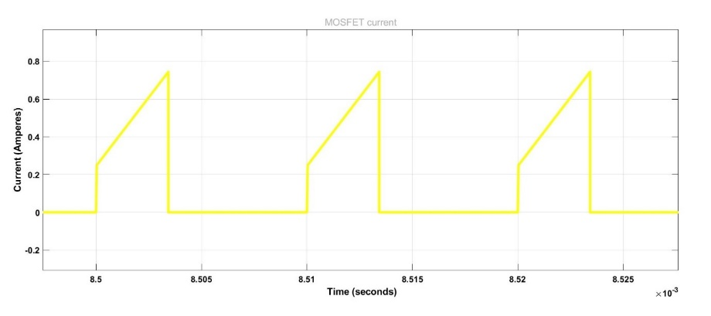
Figure 23 Switch current
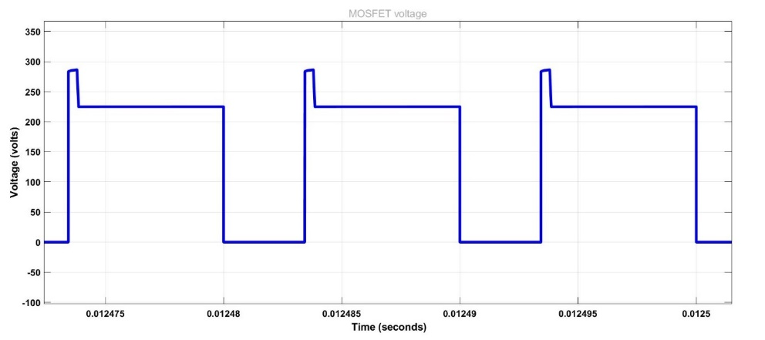
Figure 24 Switch voltage
The measured value for the MOSFET voltage is 224.9 V.
- Diode
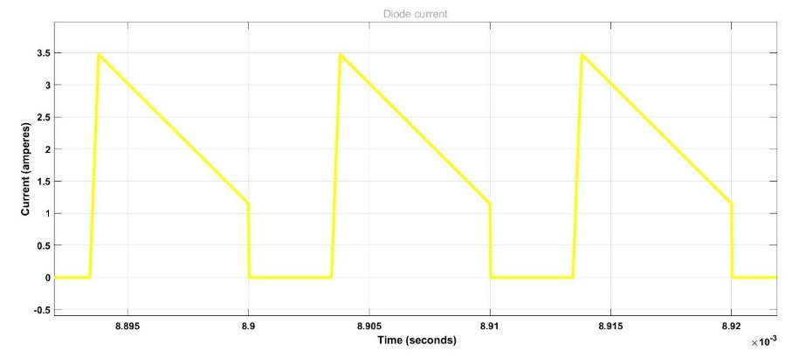
Figure 25 Diode current
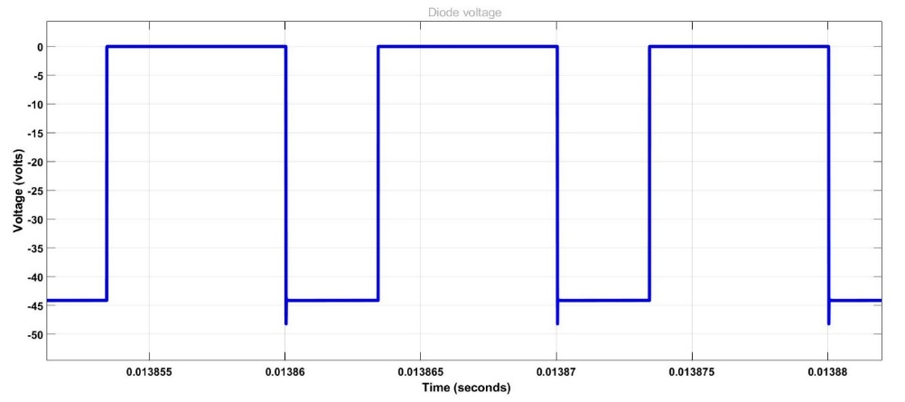
Figure 26 Diode voltage
The measured value for the diode voltage is -44.10 V.
- Inductor
The inductor waveforms could not be included because the magnetizing inductor LM is located inside the transformer in Simulink.
- Capacitor
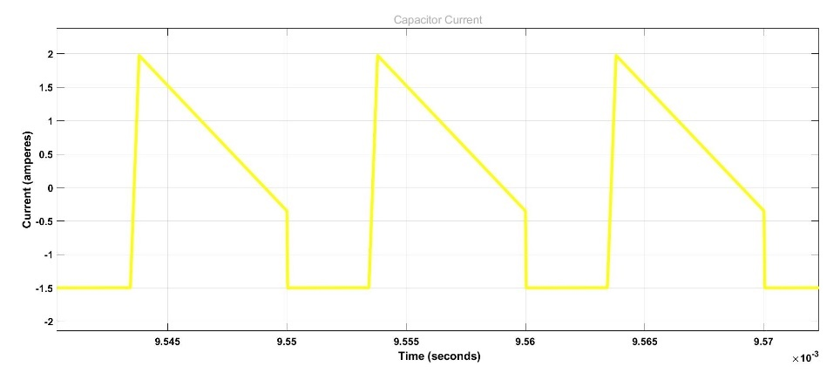
Figure 27 Capacitor current
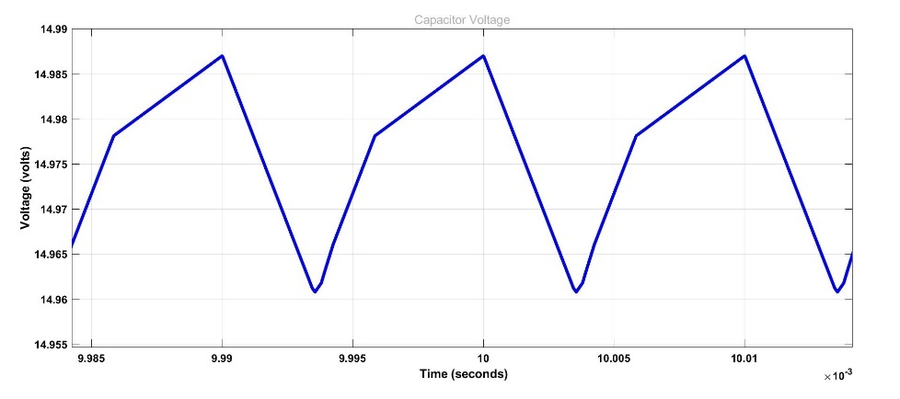
Figure 28 Capacitor voltage
The value for the capacitor voltage ripple is 0.02613.
- Transformer
The input and output voltage waveforms for the transformer are shown below.
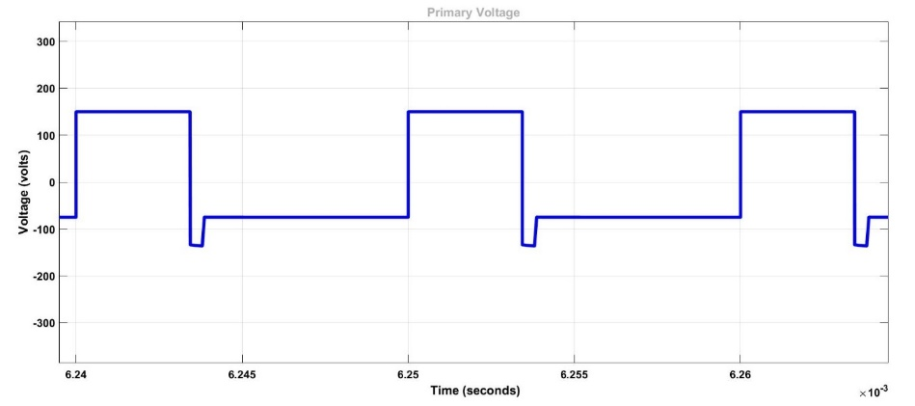
Figure 29 Transformer primary voltage
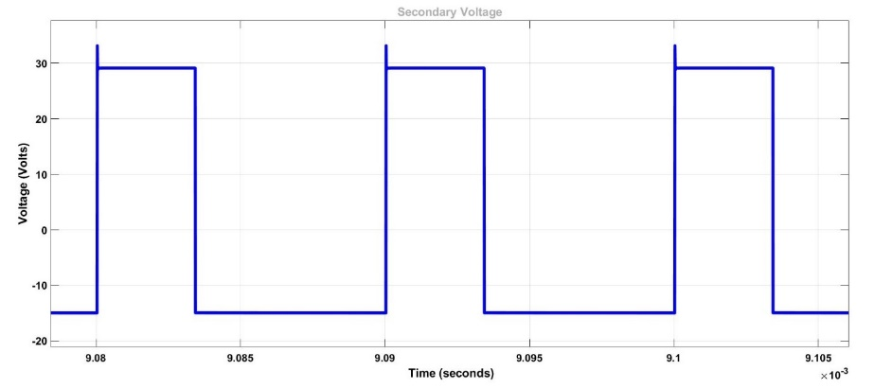
Figure 30 Transformer secondary voltage
- Theoretical calculations vs Simulation
The table below compares the values of the theoretical calculations with simulated values.
Table 5 Calculated vs simulated values.
 | Calculated | Simulated | Error (%)
Peak-to-peak Capacitor Voltage Ripple, $∆v$ | 0.025725 V | 0.02614 V | 1.6
Switching Frequency | 225 V | 224.9 V | 0.044
Diode voltage | -45 V | -44.10 V | 2

- Studying the Effects of Varying the Duty Cycle
The duty cycle was varied, and the measured results are shown in the table below.
Table 6 Effects of Varying the Duty Cycle
 | 20% | 34.3% [Normal] | 60%
Peak-to-peak Capacitor Voltage Ripple, $∆v$ | 0.009784 V | 0.02613 V | 0.1211 V
Output voltage, V_{O} | 7.24 V | 14.99 V | 41.13 V
Output current, I_{O} | 0.724 A | 1.499 A | 4.113 A

- Studying the Effects of Varying the Frequency
The frequency was varied, and the measured results are shown in the table below.
Table 7 Effects of Varying the Frequency
 | 50 KHz | 100 KHz [Normal] | 200 KHz
Peak-to-peak Capacitor Voltage Ripple, $∆v$ | 0.05499 V | 0.02613 V | 0.01274 V
Output voltage, V_{O} | 15.9 | 14.99 V | 14.57 V
Output current, I_{O} | 1.59 | 1.499 A | 1.457 A

DISCUSSION
In Figures 22-30, the flyback converter possesses the regular waveforms of a buck-boost converter. It was not possible to obtain the waveform for the magnetizing inductor since it is located inside the coupled inductor (transformer). The waveforms for the primary and secondary voltages for the transformer were obtained in Figure 29 and 30. It shows the winding voltage of 150 V and 30 V, respectively. The calculated and simulated values were very similar in magnitude as shown in Table 5. The small discrepancies are due to the internal losses in the circuit.
The duty cycle was varied as shown in Table 6. Increasing the duty cycle increased the capacitor voltage ripples, the output voltage and the output current. Therefore, the duty cycle can be used to control the magnitude of the output, although, the ripples would increase which means more filtering would be needed.
Increasing the switching frequency reduces the capacitor voltage ripples, output voltage and output current as shown in Table 7. Increasing the switching frequency could replace the use of large filter elements and is ideal in low power application or applications in which space is important.

CONCLUSION
Flyback converters are isolated converters that use coupled inductors instead of isolation transformers. Isolation could help in safety applications, reducing transformer size, minimizing current stresses, and creating more outputs. In this experiment, Simulink was used to study a flyback converter. It was found to behave like a regular buck boost converter. An increase in the duty cycle led to an increase in capacitor voltage ripples, output voltage and output current. While increasing the frequency led to a decrease in voltage ripples, output voltage and output current.

CLOSED LOOP PWM CONTROLLER LABORATORY

INTRODUCTION
In this experiment, a boost converter which is controlled by a closed loop PWM controller was modelled and simulated using Proteus. The purpose of a closed loop controller is to maintain a constant output under load variations and input variations. The Closed Loop PWM controlled boost converter is shown below.
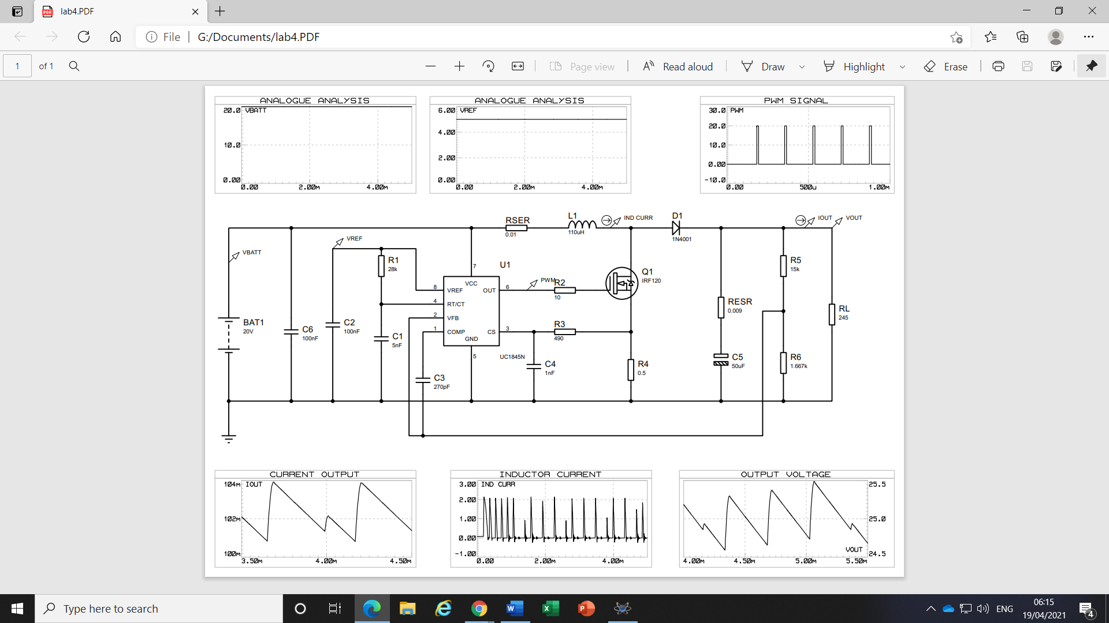
Figure 31 Buck Boost converter with closed loop control

PROCEDURE
The waveforms obtained from the simulation are shown below:
Figure 32 PWM Signal
Figure 33 Output current
Figure 34 Output Voltage

Figure 35 Inductor Current
- Comparing Measured and Calculated Values
When R1 is 28KΩ,
The measured value for the period of the PWM is 173uS. The duty cycle of the PWM is 0.064. The output voltage ripple is 0.8V. The output current ripple is 3mA and the inductor current ripple is 2.13A
Period, T of the PWM signal from the graph is 359u – 186u = 173u, frequency, F = 5.78KHz and the TON is 197u – 186u = 11u. Duty cycle is TON/T = 11u/ 173u = 0.0636 or 6.36%
While the calculated values are,
From the datasheet of UC1845N
$$f_{osc}=\frac{1.72}{R_{RT}×C_{CT}}$$

$$f_{osc}=\frac{1.72}{28k×5n}$$

$$f_{osc}=12.29KHz$$
Switching frequency is half of oscillator frequency = 12.29 / 2 = 6.145KHz
Period, T is = 162.7u
$$Inductor current ripple,∆i_{L}=\frac{V_{g}}{L}DT$$
$$∆i_{L}=\frac{20×0.065×173u}{110u}=2A$$
$$Output voltage ripple, ∆V_{O}=\frac{V_{O}×DT}{RC}$$
$$∆V_{O}=\frac{25×0.065×173u}{245×50u}=0.0229V$$
A summary of the measured against the calculated values are shown in the table below,
Table 8 Measured vs Calculated Values.
 | Measured Values | Calculated Values | Error(%)
Switching frequency | 5.78KHz | 6.145KHz | 6.31
Period, T | 173u | 162.7u | 5.9
$$Inductor current ripple,∆i_{L}$$ | 2.13A | $$2A$$ | 6.1
$$Output voltage ripple, ∆V_{O}$$ | 0.8V | $$0.0229V$$ | 97

- Investigating the Variation of R1
When R1 is 50KΩ,
Period, T of the PWM signal from the graph is 631u – 325u = 306u and the TON is 336u – 325u = 11u. Duty cycle is TON/T = 11u/ 306u = 0.0359 or 3.59%
While the calculated value is,
From the datasheet of UC1845N
$$f_{osc}=\frac{1.72}{R_{RT}×C_{CT}}$$

$$f_{osc}=\frac{1.72}{50k×5n}$$

$$f_{osc}=6.88KHz$$
Switching frequency is half of oscillator frequency = 6.88 / 2 = 3.44KHz
Period, T is = 290.698uS.
The output voltage ripple is 0.8V. The output current ripple is 3mA and the inductor current ripple is 2.139A

When R1 is 10KΩ,
Period, T of the PWM signal from the graph is 387u – 324u = 63u and the TON is 335u – 324u = 11u. Duty cycle is TON/T = 11u/ 63u = 0.175 or 17.5%
While the calculated value is,
From the datasheet of UC1845N
$$f_{osc}=\frac{1.72}{R_{RT}×C_{CT}}$$

$$f_{osc}=\frac{1.72}{10k×5n}$$

$$f_{osc}=34.4KHz$$
Switching frequency is half of oscillator frequency = 34.4 / 2 = 17.2KHz
Period, T is = 58.14uS.
The switching frequency changes. When R1 is higher the switching frequency reduces but when R1 is lower the switching frequency increases.
The output voltage ripple is 0.7V. The output current ripple is 3mA and the inductor current ripple is 2.14A
- Increasing Relevant Components
The components that need to be adjusted for the output voltage to increase are the resistors forming the voltage divider. From the datasheet of UC1845N the formula for calculating the resistors to be changed was gotten and is given below,
$$V_{OFFSET}=\frac{R_{CSF}}{R_{CSF}+R_{P}}×V_{REF}$$
V_{OFFSET} is 2.5V and was acquired from the datasheet of UC1845N.
Since a 5% increase is required to the output voltage V_{REF} is calculated to be,
$V_{REF}=5\%×V_{O}+V_{O}$ (V_{O} is 25V and was measured as the output)
$$V_{REF}=0.05×25+25$$
$$V_{REF}=26.25V$$
R_{CSF} was selected to be 3kΩ, the value of R_{P} needs to be determined,
$$R_{P}=\frac{R_{CSF}×V_{REF}}{V_{OFFSET}}-R_{CSF}$$
$$R_{P}=\frac{3k×26.25}{2.5}-3k$$
$$R_{P}=28.5kΩ$$
The values of 3kΩ and 28.5 kΩ were used in the voltage divider and the output voltage was observed to be 26.25V as shown in the graph below,
Figure 36 Output voltage

DISCUSSION
The figures 32-35 show the normal operation of a boost converter during switching cycles. The calculated values were lower than the measured values of the period of the PWM signal as shown in Table 8. This is due to non-ideal characteristics inherent in the circuit. This was also the case for the switching frequency and the inductor ripple current. Although, the calculated and measured values of the output voltage ripple were far in valuation. This is due to the components in Proteus spiking the ripple.
It was observed that increasing the magnitude of the resistor R1 connected to the VREF and RT/CT would mean reducing the switching frequency of the PWM and vice versa. Although, the output voltage, ripple current and voltage remained the same.
Controlling the output voltage is performed using the voltage divider providing a feedback to the VREF pin from the output voltage. The reference voltage and resistors for the voltage dividers need to be determined then feedback is sent to the integrated circuit which uses a comparator circuit to correct the signal to the MOSFET (switch).

CONCLUSION
The purpose of a closed loop PWM controller is to maintain a constant output under load and input variations. A boost converter was modelled using Proteus and the switching frequency was controlled using the resistor R1 connected to the VREF and RT/CT. The magnitude of the load was controlled by adjusting the resistors which form a voltage divider at the output and sends feedback to a comparator.

